Project Name |  | Confidentiality Level
XX Project |  | For Recipients’ Reference Only
Project ID | Version | Document Code
 |  | Project ID_SD_001

XX Software System Design Specification



Copyright © Ruankosoft Technologies(Shenzhen), Co., Ltd.
. All Rights Reserved
Revision Record
Date | Revision Version | CR ID /Defect ID | Sec No. | Change Description | Author

Content
1 Introduction 5
1.1 Purpose 5
1.2 Scope 5
1.2.1 Name 5
1.2.2 Functions 5
1.2.3 Applications 5
2 Level 0 Design Description 5
2.1 Software System Context Definition 5
2.2 Design Considerations 5
2.2.1 Design Alternatives 5
2.2.2 Design Constraints 5
2.2.3 Other Design Considerations 6
3 Level 1 Design Description 6
3.1 System Architecture 6
3.1.1 Description of the Architecture 6
3.1.2 Representation of the Business Flow 6
3.2 Decomposition Description 6
3.2.1 Module/Subsystem 1 Description 6
3.2.2 Module/Subsystem 2 Description 6
3.3 Dependency Description 6
4 Level 2 Design Description (Optional) 6
4.1 Module Name 1 7
4.1.1 Design Description 7
4.1.2 Function Illustration 7
4.2 Module Name 2 7
4.2.1 Design Description 7
4.2.2 Function Illustration 7
5 Data Structure/Database Design 7
6 UI Design 7
7 Detailed Design of Module 8
7.1 Class1 Design 8
7.1.1 Overview 8
7.1.2 Class Diagram 8
7.1.3 Attributes 8
7.1.4 Methods 8
7.2 Class2 Design 9

Keywords:
Abstract:
List of abbreviations: Describe abbreviations in this document, full spelling of the abbreviation and Chinese explanation should be provided.>
Abbreviations | Full spelling | Chinese explanation

- Introduction

Purpose
This document describes the process of software development and development of the details to facilitate the development of developers

Scope
    - Name
Super Contract Manage System

    - Functions
refer to Software Requirements Specification
    - Applications
This Software is a web application.
- Level 0 Design Description

Software System Context Definition

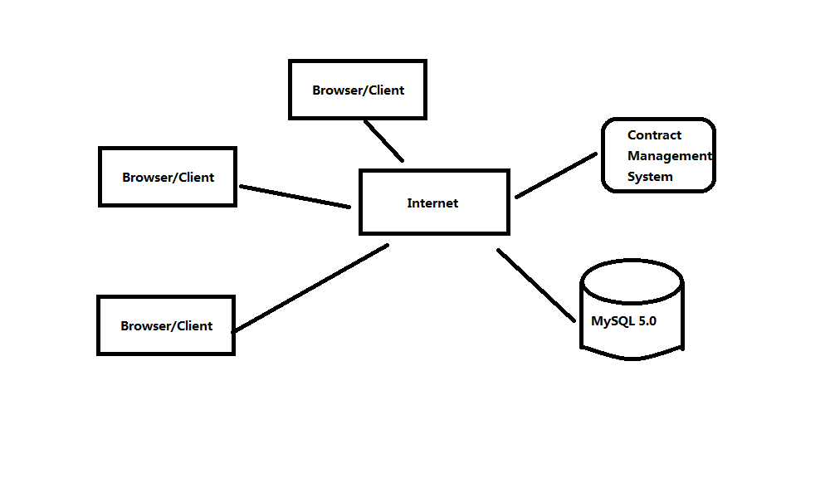Design Considerations
    - Design Alternatives
- three layer structure of system
A system can be divided into view layer,business logic layer, and data access layer,packet respectively are (com.ruanko.web),(com.ruanko.service),(com.ruanko.dao),they call business model class(is com.ruanko.modelthe class of packets) to transfer the data,some of classes are used publicly in several places, as a tool,Then put them together in a com.ruanko.utils packets.

- the developments model of project and three layer structure
A system use Model 2 development Model:JSP+Servlet+JavaBean(MVC),it combines with three layer structure ,servlet (controller) and JSP page(view) pose as view layer,JaveBean is model (including business logic,data access and entity model class and so on)pose as business logic layer and data access layer.

- the directory structure of project
The packet hierarchical structure of combine three layer structure with Model 2:
Project structure | directory
View Layer(UI) | JSP Files
 | com.ruanko.web
Business Logic Layer(BLL) | com.ruanko.service
Data Access Layer(DAL) | com.ruanko.dao
 | com.ruanko.dao.impl
Entity | com.ruanko.model

The directory of folder:
folder | Brief descriptions
css | To store style files
images | To store picture files
js | To store script files
upload | To store files to be upload

    - Design Constraints
      - Standards compliance
Hardware Limitation
CPU:1GHZ
RAM:128MB
To ensure that the system can run smoothly,the configuration best meet the following requirements:
CPU:1.8GHZ
RAM:1G

      - Technology Limitations
Database:MySQL5.X
Coding standard:CEO projecting standard requirement of Ruanko Lab.
    - Other Design Considerations
Should use the compiler Eclipse
- Level 1 Design Description

System Architecture
    - Description of the Architecture
System Architecture:
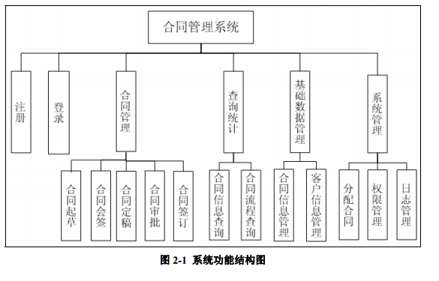
    - Representation of the Business Flow

Decomposition Description

    - Contract Manage Description
- Overview
Provide contract management process
- Functions
Management contract drafted to sign the entire process

    - Query stats Description
1. Overview
Provide query function
2. Functions
You can query the details and status of the contract
    - Basic data management Description
1. Overview
Manage information about the entire system
2. Functions
Contract information and user information management
    - System Management Description
1. Overview
Management of whole system
2. Functions
Distribution contract, rights management and log management
    - Register and log in Description
1. Overview
Log in and register
2. Functions
Log in and register

Dependency Description
- 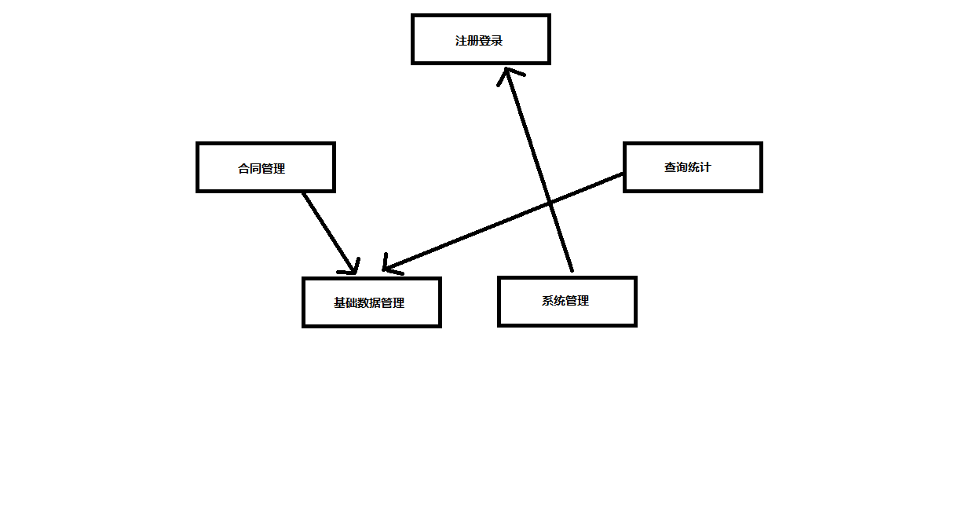Level 2 Design Description (Optional)

Login and Logout and Register Module
.
    - Design Description
This is the item login registration and exit function
      - LoginServlet
(1) Overview
Log in and get user permissions to jump to the appropriate interface

(2) Definition (Optional)
Class diagrams or pseudo codes could be used to depict the class definitions in detail，if it is not described previously. All the public attributes and methods should be defined specifically.
      - LogoutServlet
- Overview
Logout
- Definition (Optional)
      - Rigister
(1)Register and write user information to the database

    - Function Illustration
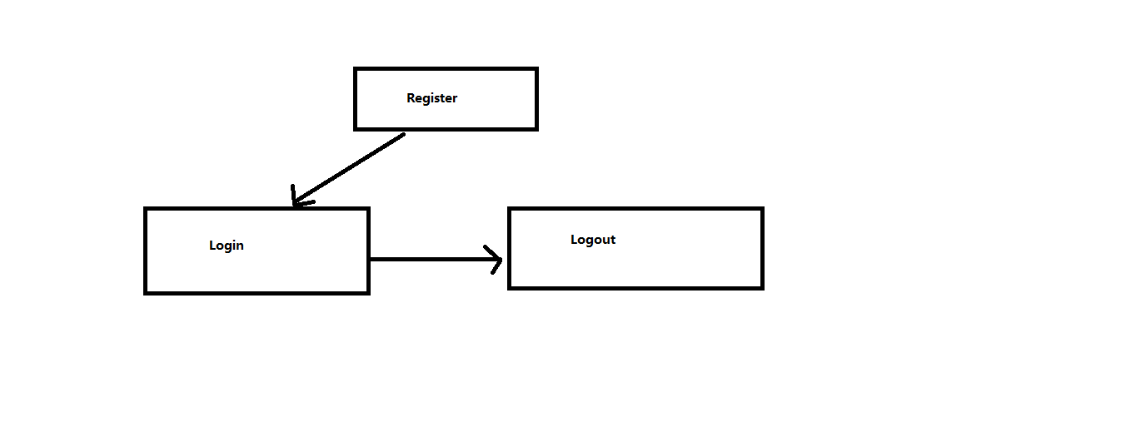

Contract operation
    - Design Description
Contract a series of operations
      - DraftContractServlet
- Draft the contract and deposit it into the database
      - CountSignContractServlet
- CountSign the contract and store the data in the database
      - ApproveContractServlet
- Review the contract and approve it
      - SignContractServlet
- Sign the contract and deposit it in the database
      - AsignContractServlet
- Assign the contract to the user and store it in the database
      - TerminateContractServlet
(1)Terminate the contract that has been signed
    - Function Illustration
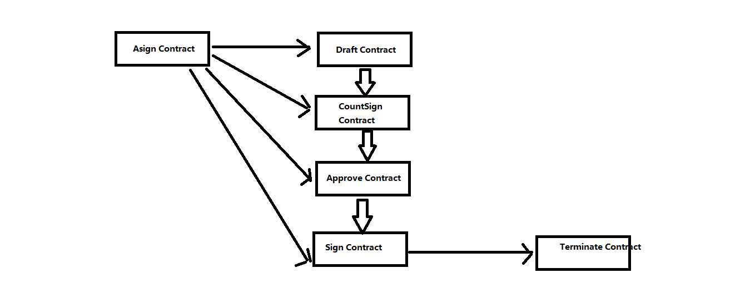

Query operation
    - Design Description
The query operation of the contract
      - QueryContractServlet
- Find all contract information
      - QueryContractProcessServlet
- Query all contract status

System Manage
    - Design Description
User and Role Managment
      - UserManagementServlet
- add modify and delete user information
      - RoleManagementServlet
- add modify and delete role information
      - RightsAssignmentServlet
(1)Assign the role to the user
- Data Structure/Database Design
Store the page information in the jsp file
- UI Design
In each user's interface to show all the features, no permission to click the link will remind users of limited permissions
- Detailed Design of Module

Login Design
    - Overview
Get the login information and get permission
    - Class Diagram
Class diagram, if not described in HLD.
    - Attributes
The common data structure should be described here.
Visibility | Name | Type | Brief descriptions
False | id | int | Get the user id
True | name | String | Get the user name
True | Password | String | Get the user password
    - Methods
Every method should be described.
      - Method1
(1) Method Descriptions
Prototype | String
Description | Get the user’s role by user’s id
Calls | getRoleById()
Called By | loginServlet
Input | User’s id
Output
Return | User’s role
Exception

(2) Implementation Descriptions
UserService.getRoleById(id);
If(role.getname()==admin)
Turn to admin interface;
Else
Turn to operation interface;

